EQUATOR RESOLUTION
Institutional Mediation, Conciliation & Settlement

Forum Interface Map
Where each financial dispute goes — and how Equator fits alongside

Financial & Loan Dispute Resolution vertical
July 2026 · Draft for legal sign-off · www.equatorresolution.com

The map at a glance
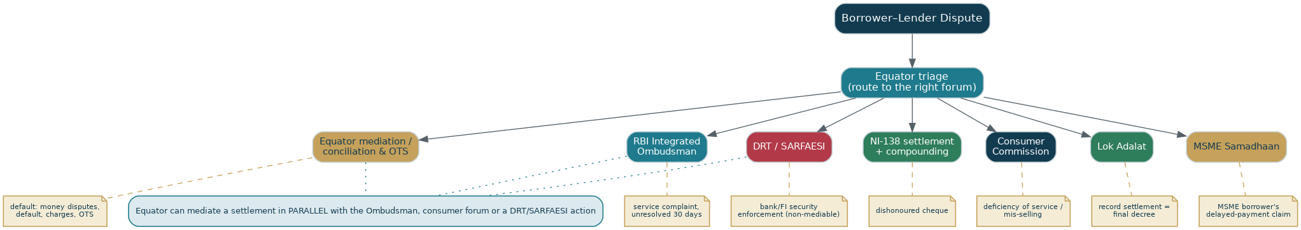
Figure — Equator triage routes each dispute to the right forum, and can mediate a settlement in parallel.
This map shows where each type of financial dispute properly belongs, and where Equator's neutral mediation and settlement adds value — often in parallel with a statutory forum.
1. Forum-by-forum
Forum | When it applies | Equator's interface
Equator mediation / conciliation & OTS | Default, charges, restructuring, OTS, most borrower–lender money disputes. | Primary route; escrow-secured; enforceable settlement.
NI-138 settlement + compounding | A dishonoured cheque for a debt. | Mediate + compound (s.147); or record in Lok Adalat.
RBI Integrated Ombudsman | A service complaint against a bank/NBFC/PSO unresolved by the lender in 30 days. | Free, borrower-only escalation; Equator mediates money in parallel.
DRT / SARFAESI | Bank/FI enforcement of security or recovery above the threshold. | Statutory, non-mediable; Equator mediates an OTS around it.
Consumer Commission | Deficiency of service or unfair trade practice (mis-selling, wrong charges). | Consumer remedy; settlement can resolve it faster.
Lok Adalat | Any settlement the parties want recorded as a final decree. | Award = civil-court decree, non-appealable.
MSME Samadhaan | An MSME's own delayed-payment claim (as supplier). | For MSME borrowers who are also aggrieved suppliers; separate from their loan.

One front door
A borrower or lender does not need to know which forum fits — Equator's triage (and the AI Dispute Explorer) routes the matter and, wherever lawful, offers a mediated settlement alongside.

